Livestock Cattle GPS Monitoring Solutions
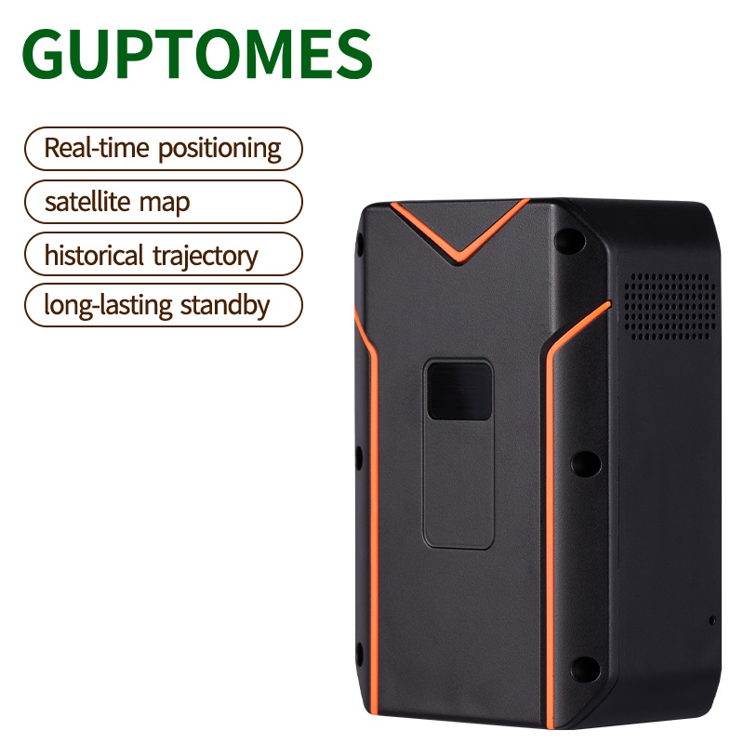
Price：$82.6
Product model：S10
Product parameter：
Positioning technologies | GPS+BDS+WIFI+LBS+AGPS
Positioning accuracy | satellite position 5-15 meters
Base station positioning | 50-1000 meters
Size | 106*71*45mm
Battery | 20000mAh
Weight | 412g
Super long standby time | 5-6months
Box Dimensions (per unit) | 21*14*11cm
Product feature：
• Versatile Positioning: Utilizes GPS+BDS+WIFI+LBS+AGPS for comprehensive and accurate location tracking.
• Rugged Design: The tracker is built to be durable and resistant to external influences, as seen by its use for livestock.
• Super Long Standby: The device can last for 5-6 months in standby mode, which is ideal for long-term monitoring.
• Built-in Satellite Map: Comes with a built-in map for easy visualization of location
Product function：
• Real-Time Tracking: Provides live location data for instant monitoring.
• Historical Trajectory: Allows users to view and analyze past routes and movements.
• Geo-Fence: Users can set up a virtual boundary and receive alerts if the animal exits or enters the designated area.
• Built-in Satellite Map: The tracking information is displayed on a built-in map for easy visualization.

